North Bay REVISED – new website address

Christian Academy <https://secure.ministrysync.com/ministrysync/event/?e=13735>

Feed the Hungry Pack-A-Thon

2018 Fundraising Event through FundEasy

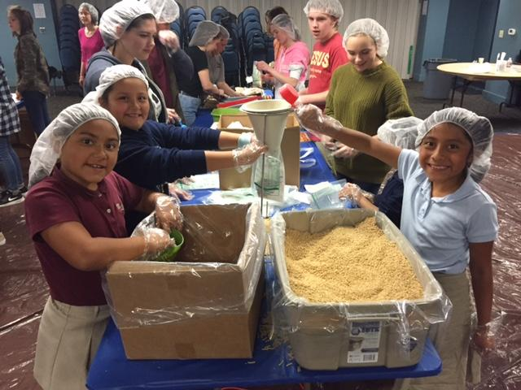 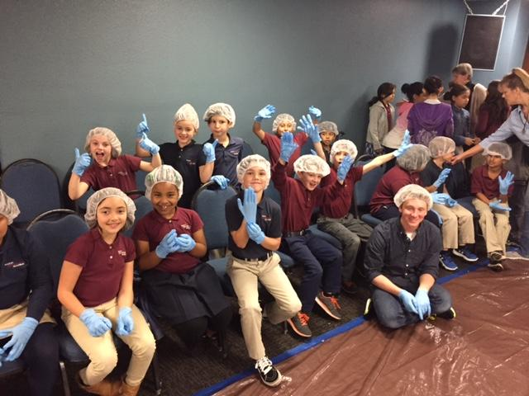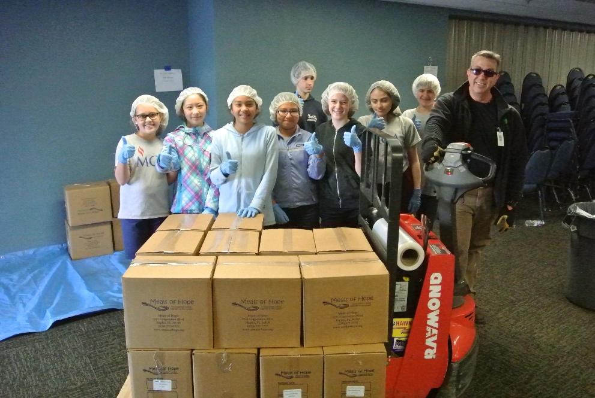

In Partnership with Cornerstone Consulting Group



This amazing organization gives us the opportunity to pack and provide 10,000 meals for people in our local community who need food. Volunteers walk away feeling great about giving back and as a school our students can participate in creating lasting memories!

**Tuesday, MARCH 20th**

**PLEASE READ** each item so that you have the understanding of how we are asking each family (or individual) to participate. If you have any questions, please contact the school office: Heather Freeman 415-892-5713 or at hfreeman@marinchristian.org

* **CREATE** your very own FundEasy Fundraiser page! VISIT the main event page [**https://secure.ministrysync.com/ministrysync/event/?e=13735**](https://secure.ministrysync.com/ministrysync/event/?e=13735) and click “Participate” (detailed instructions on page 2). This is how we raise money for the school wide fundraiser.
* **PRIZE SHEET** is attached so your student can win fun items while collecting donations. Donations will go to Feed the Hungry Pack-A-Thon, Marin Christian Academy, Noah’s Ark Preschool, and North Bay Christian Academy.
* **PACK-A-THON EVENT** on Tuesday, March 20th for students and volunteers to help pack 10,000 meals. Event will be in the chapel from 8am-11:30am. Contact the school office if you would like to volunteer.
* **DINNER FUNDRAISER** is for all families and friends! Bounce houses will be on campus for everyone to enjoy. Join us anytime from 5pm-7:30pm on Tuesday, March 20th

***PACK-A-THON EVENT DETAILS:***

What does the meal consist of?

Fortified cheese mixture (in a packet), soy, and elbow macaroni… total of 3 ingredients

How does it all get packed?

1 meal = 1 serving

192 meals per box

52 boxes total

Each box will weigh about 28 lbs.

Students will help pack meals assembly line style from 8am-11:30am on Tuesday, March 20th in the chapel on the MCA Campus. This is an amazing experience for volunteers, school staff, faculty and students.

***SCHOOL-WIDE FUNDRAISER through FundEasy***

Follow these steps to create a personal fundraising page for your family

1. Visit the main event page [**https://secure.ministrysync.com/ministrysync/event/?e=13735**](https://secure.ministrysync.com/ministrysync/event/?e=13735)and click “Participate” (please note there is no “www” in the link)
2. Here, you’ll choose a username and password and fill out some information about yourself. (You’ll use this information each time you need to log in to your fundraising site.) Click “Continue”.
3. Next, you’ll be prompted to add a photo of yourself or your family.
4. As you scroll down, you’ll be given the opportunity to turn on sharing options for email, Facebook, or Twitter. **Be sure to enable e-mail.** Whether you enable Facebook or Twitter is up to you. They can always be turned off later by changing your profile settings.
5. At this point, you can personalize your site wherever you see a **YELLOW** button on your page. NOTE: These are the only placed where your page can be customized.
6. IMPORTANT: From your fundraising website, you’ll be able to send emails asking if they will donate to your school. Here’s what to do:

In the “Spread the Word” box at the bottom right, click on the “Send E-Mails” link, and follow the simple instructions. **This will open an empty e-mail in your preferred email program where you can type a simple message to potential donors.** We recommend entering email address unto the BCC field so that the e-mail addresses are kept private.

**Don’t forget to be the first to make a personal donation through your website!** You’ll be setting the precedent for others to give generously to your organization, since your name will show up as a donor on your own page. The suggested goal is $300/family

How to achieve our goal of $20,000?

Each of our families raise $300

20 families donate $1000

Where does the money go?

Educational Software for Noah’s Ark, MCA and NBCA

New hands on play equipment for preschool with S.T.E.M applications

10, 000 Meals to distribute throughout the community

**FREQUENTLY ASKED QUESTIONS**

**Q.** **How do I raise the goal of $300**

A. The goal of $300 is just that……a goal! That being said, raising $300 is an attainable goal if you follow the fundraising process that has been described… in other words, sending emails, forwarding to social media or sending out letters along with follow up calls. For example, if a family or individual sends out emails and makes follow-up phone calls, it is not unusual to achieve a response rate of over 70%. If 30 out of 40 people give $10.00, that would reach your goal of $300.

**Q:** **I really don’t like fundraising. Is there some other way to participate?**

A: Of course, you may opt out with a $250 donation. However, remember this event is not only about raising much needed funds, but it also provides you a wonderful opportunity to tell others about your organization. If everyone will send out emails, forward to social media and make a follow up phone call, the fundraising goal of $20,000 can be reached.

**Q**: **Why do I have to make a follow-up phone call to each of my prospective donors?**

A: The simple, one word answer is: results. If a person sends out emails and does not make any follow up phone calls, the overall response rate will be around 10% to 15%. On the other hand, if a person makes a follow up phone call to each prospective donor, the overall response rate increases to at least 60%! This means we can raise at least 4x more money if everyone that is participating will make a follow-up phone call to each of their prospective donors.

**Q:** **Won’t people be offended if I can ask for money?**

A: Not at all. The worst thing that can happen is that someone simply says, “No”. In fact, people will generally have a greater respect for you because you were willing to ask for a donation for a cause that you believe in so strongly.

***DINNER FUNDRAISER 5pm-7pm March 20th***

Join us after the pack-a-thon event later that evening for another opportunity to support our schools. Complete dinner menu and details to follow within the next couple of weeks. Bounce House activities will be available for all friends and families to enjoy!